**Gupteshwor Mahadev Multiple Campus**

**(GMMC)**

**Lab report: Software Engineering**

|  |  |
| --- | --- |
| **Submitted by** | **:Nishan shah** |
| **Registration no** | **:7-2-781-273-2020** |
| **Exam no** | **:12270/20** |
| **Submitted to** | **:Suresh Baral** |
| **Signature** | **:…………………** |

**Contents**

1. **a)** **You need a software that stores the data about people like name date of birth gender height weight and also facilitates users to see the records of either males only or females only, see records of a person with height or weight greater than the given information, see the records of people with the given date of birth. Now draw use case diagram for above scenario.** 2
2. **b)** **Draw an activity diagram that models the data processing involved when a customer withdraws cash from the ATM** 3
3. **c)** **restaurant uses information system that takes customer order, sends the order to the kitchens, monitors the good sold, updated inventory and generates report for management. Draw sequence Diagram for above scenario.** 4
4. **d)** **Draw class diagram for Hospital Management System. Assume your own Class, attributes and operations.** 5
5. **e)** **A Professor has a name, address, phone number, email address and salary. A student has also name etc. but not salary. A Student however has a mark. A Course has a name and number. A student is enrolled in course and marks of this enrolment is recorded. Pofessor teach course. There are two type of courses bachelor and Masters. Make a class Diagram for this scenario. Add attributes and methods whenever necessary.** 6
6. **f)** **Create an Activity Diagram for voting your favourite singer in The Voice of Nepal. Include various action states (initial and final action states), Swimlanes, Control flow transitions, and object flow transition.** 7
7. **g)** **Create an Activity Diagram for voting your favourite singer in The Voice of Nepal. Include various action states (initial and final action states), Swimlanes, Control flow transitions, and object flow transition** 8
8. **h)** **You as a developer is requested to Develop a simple console-based application for teachers to create quizzes for the students. Teacher just wants to manage his/her quizzes and questions. System should provide the functionality to add new quiz and then add some questions to that quiz. All the questions would be MCQs. For each question, Teacher will store the question number, question details, options of the question and the right option. Draw Class Diagram for mentioned case.** 9
9. **i)** **In Library system any person can apply for membership. Once the person gets membership, books can be issued. To issue book member must provide membership card. Library system verifies validity of the card and if card is valid, book is issued. While returing books library system checks the due date of the books and charges fine for overdue books. Members can also search reserve books by providing card number to the system. Draw use case Diagram and sequence diagram** 10

# **You need a software that stores the data about people like name date of birth gender height weight and also facilitates users to see the records of either males only or females only, see records of a person with height or weight greater than the given information, see the records of people with the given date of birth. Now draw use case diagram for above scenario.**



# **Draw an activity diagram that models the data processing involved when a customer withdraws cash from the ATM**

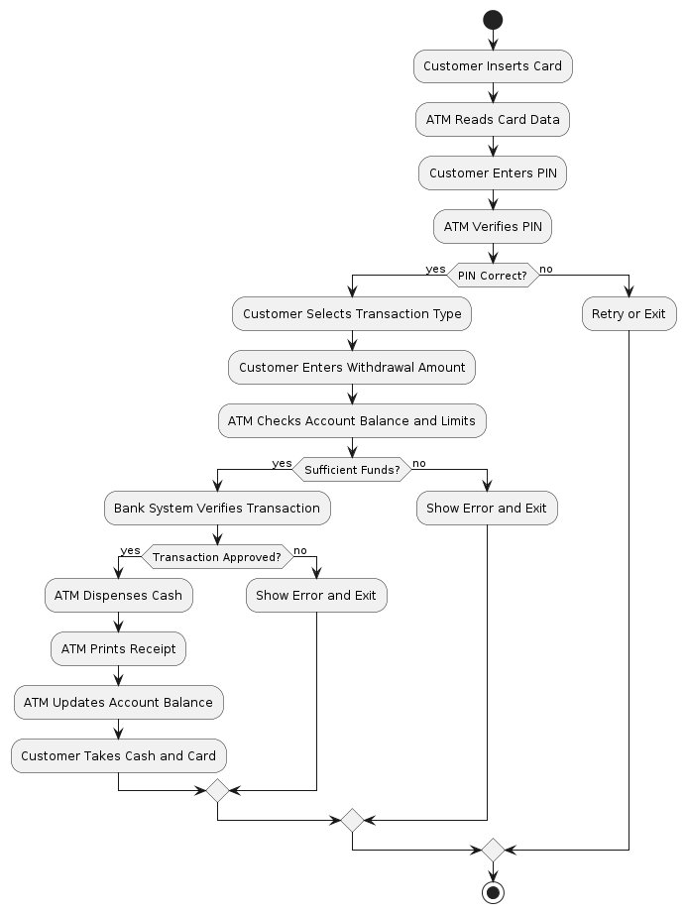

# **restaurant uses information system that takes customer order, sends the order to the kitchens, monitors the good sold, updated inventory and generates report for management. Draw sequence Diagram for above scenario.**

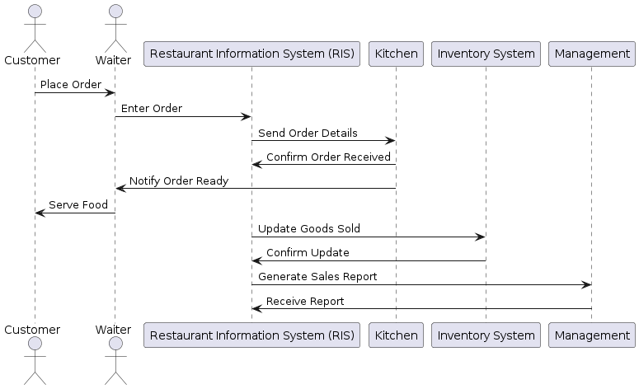

# **Draw class diagram for Hospital Management System. Assume your own Class, attributes and operations.**

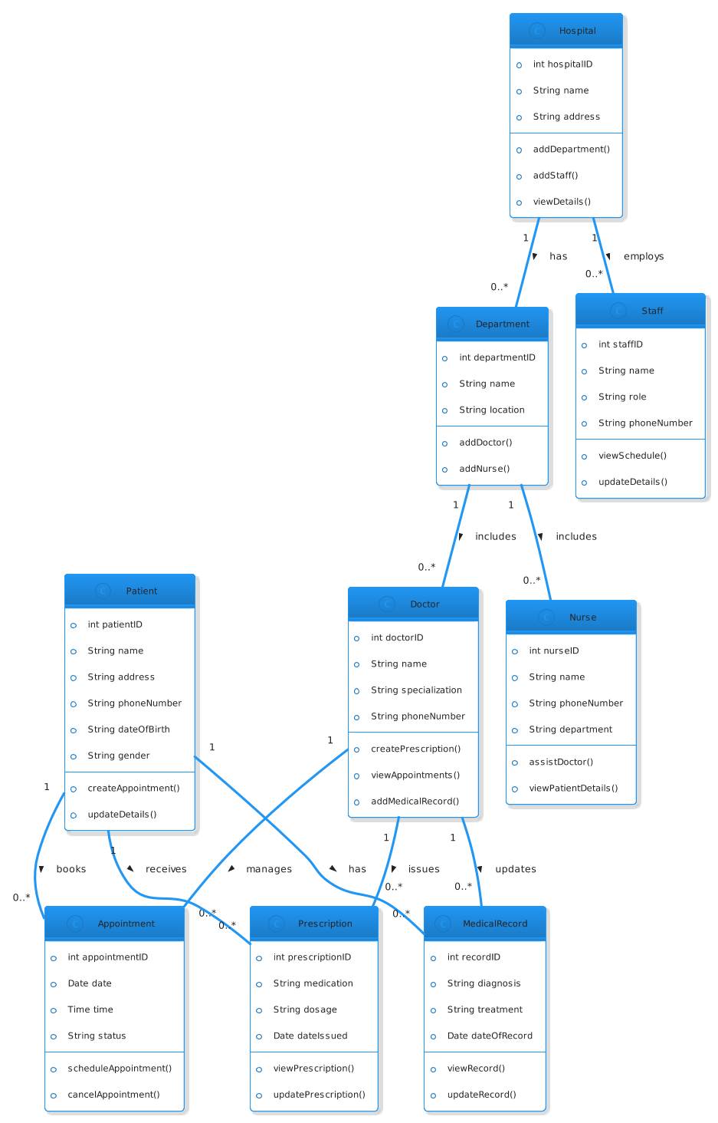

# **A Professor has a name, address, phone number, email address and salary. A student has also name etc. but not salary. A Student however has a mark. A Course has a name and number. A student is enrolled in course and marks of this enrolment is recorded. Professor teach course. There are two type of courses bachelor and Masters. Make a class Diagram for this scenario. Add attributes and methods whenever necessary.**

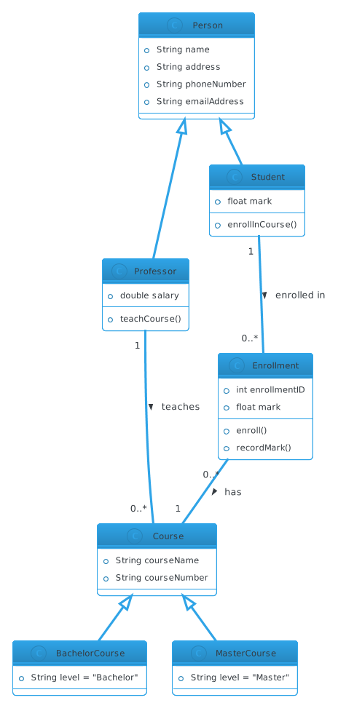

# **Create an Activity Diagram for voting your favourite singer in The Voice of Nepal. Include various action states (initial and final action states), Swimlanes, Control flow transitions, and object flow transition.**

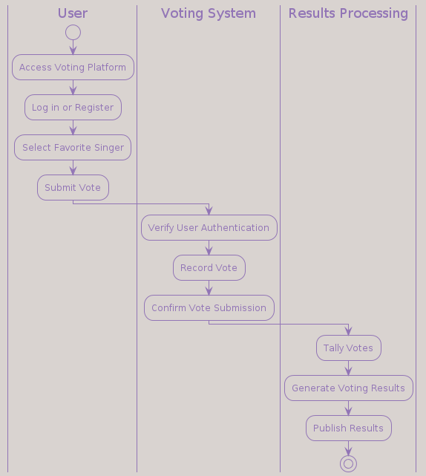

1. **Create an Activity Diagram for voting your favorite singer in The Voice of Nepal. Include various action states (initial and final action states), Swimlanes, Control flow transitions, and object flow transition.**

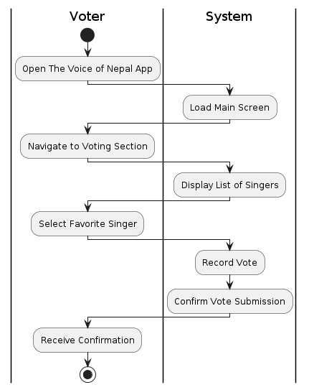

# **You as a developer is requested to Develop a simple console-based application for teachers to create quizzes for the students. Teacher just wants to manage his/her quizzes and questions. System should provide the functionality to add new quiz and then add some questions to that quiz. All the questions would be MCQs. For each question, Teacher will store the question number, question details, options of the question and the right option. Draw Class Diagram for mentioned case.**

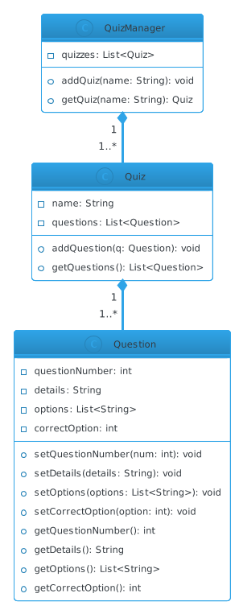

# **In Library system any person can apply for membership. Once the person gets membership, books can be issued. To issue book member must provide membership card. Library system verifies validity of the card and if card is valid, book is issued. While returning books library system checks the due date of the books and charges fine for overdue books. Members can also search reserve books by providing card number to the system. Draw use case Diagram and sequence diagram**

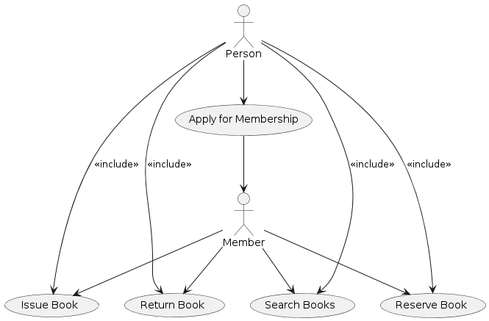

**sequence diagram**

